STOCKZ

A Zambian online stock trading mobile application

Developed By Rameez Serniabat, Mulungushi University 4th Year Computer Science student



Mobile Application User Guide

Introduction

Welcome to STOCKZ

STOCKZ is an online stock trading application that allows you to buy and sell shares from your favorite Zambian companies listed on the Lusaka Stock Exchange.

This mobile application aims to solve the issues that the current system faces such as usability, accessibility, and efficiency. This mobile application makes registration for new customers a relatively easy process. This mobile application aims to make day to day accessibility and operation easier which is a problem customers tend to face with many trading applications especially when the user has no prior experience to online stock trading. This mobile application has a graphical display of the stock prices and their fluctuations in order to give up to date insight and keep customers well informed about the state of the stock market. This mobile application allows a user to buy and sell shares and select a broker of their choice. This mobile application generally aims to make online stock trading easier and more convenient for a day-to-day trader to use as it will offer a straight forward and easy to navigate UI which will be easy to understand even for a first-time user of the application.

Compatibility

STOCKZ will be compatible with all mobile devices once deployed. Below is a condensed list of compatible devices. All Apple products require iOS 6.0 or later.

• Android phones

• Android tablets

• iPhone

• iPad

• iPod Touch

Installation

This app will be available on the Google Play Store and The Apple App Store for download once deployed.

Let’s Get Started!

Signing In

Enter your email and password into the text fields and press the sign in button to go to the dashboard.

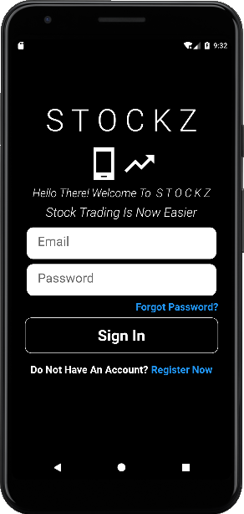

Registering An Account

Enter your personal details and password into the text fields and press the sign-up button to go to the dashboard.

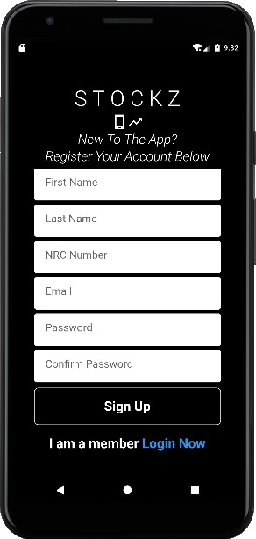

Dashboard

The dashboard view of the application, here you can scroll down and select the watchlist option to view the different markets on the watchlist.

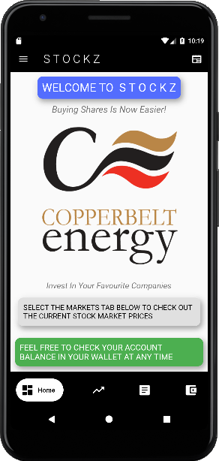

Drawer navigator

Bottom navigation bar. Here you can navigate between the different screens of the app

Business news

Markets

Here you can view the different markets and their stock prices and stock price fluctuations. You can also select a market to buy a share from or sell.

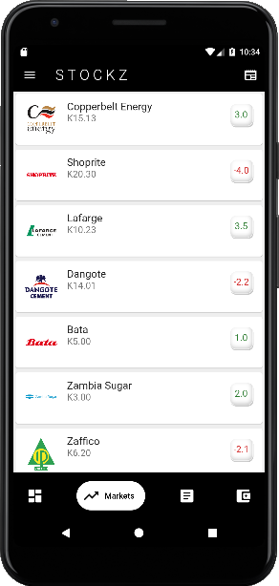

Stock price of each share from the company

Stock price fluctuation. Green indicates increase in price. Red indicates drop in share price

Viewing selected company details

Here you can view the details of the company and buy or sell shares.

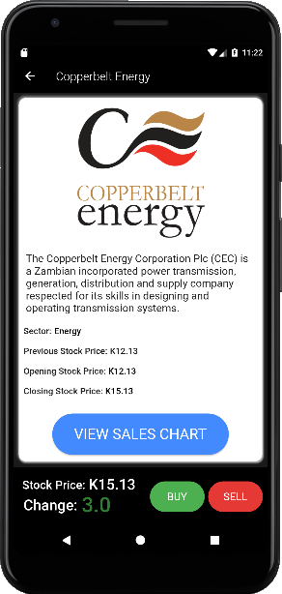

Click this button to view share sells candlestick chart

Here you can choose to buy or sell a share by clicking the respective buttons

Viewing Stock Sales Chart

Here you can view the trends of the share prices within’ a specified period of time.

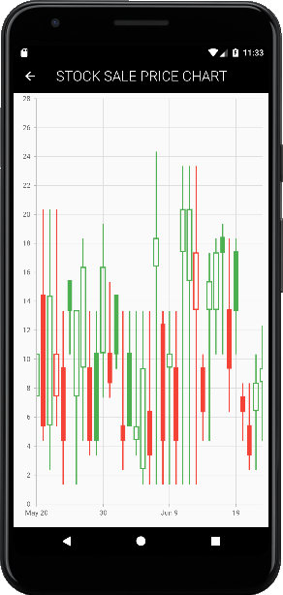

Portfolio

Here you can view your portfolio and investments.

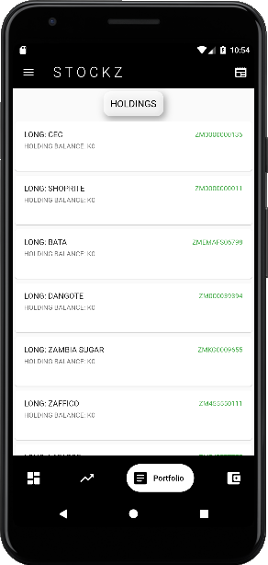

Wallet

Here you can view your wallet balance and see the different payment options this app provides.

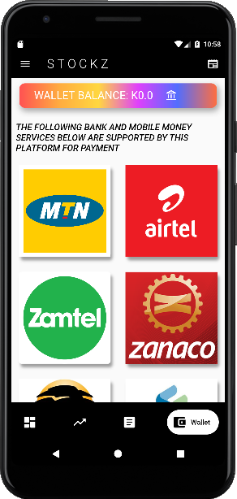

Your wallet balance is indicated here

Business News

Here you can view current affairs in the Zambian business world. You can click on a news item to view more details about the headlines.

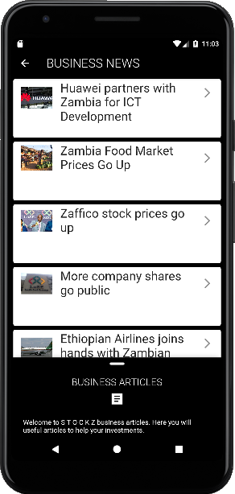

Business articles sliding up menu

Click on headline to view more details

Drawer Navigator

Found on the top left corner of the dashboard. Here you can view other options and click on your account to view your account details.

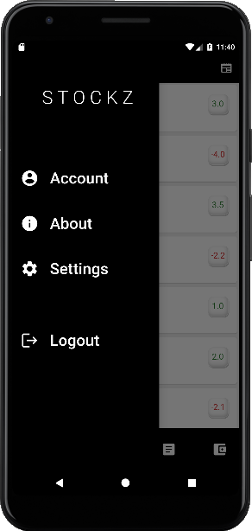

Account

Here you can view your account details and make a deposit to your wallet or withdraw from it.

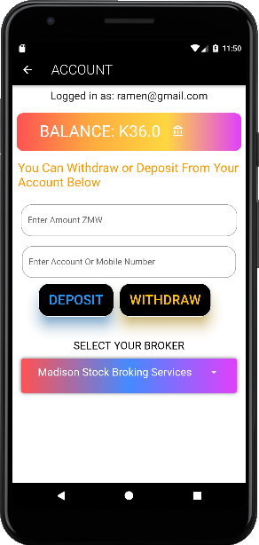

Deposit and Withdraw buttons

Your wallet balance

Select your broker from this drop-down list

Enter your amount here and your mobile money number or bank account number that you are using to deposit from or withdraw to.

Help

Any questions, concerns, or issues regarding the app may be resolved by contacting the STOCKZ developer by phone or email:

* [rameezalamserniabat@gmail.com](mailto:rameezalamserniabat@gmail.com)
* +260973364800